**Making subnets public and private**

* Overview  
  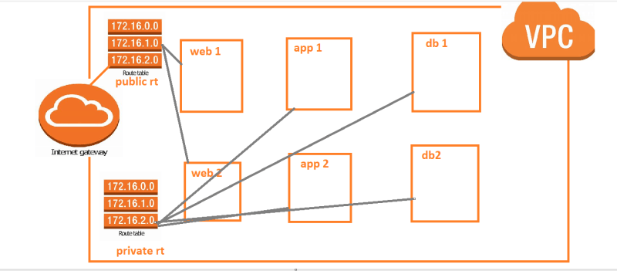
* Creating internet gateway and attach to vpc. <https://registry.terraform.io/providers/hashicorp/aws/latest/docs/resources/internet_gateway> for resource
* <https://github.com/asquarezone/TerraformZone/commit/09a06eb0e7ed5e2ad05278ab88edbe8261ee7af2> for the changes done  
  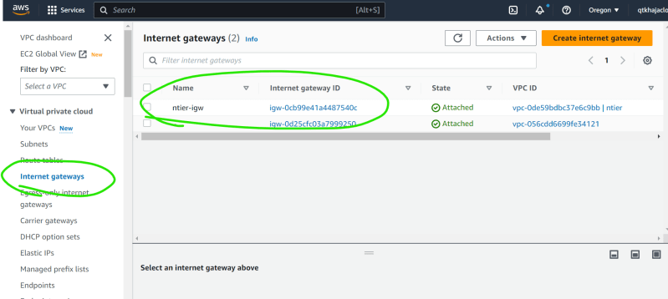
* Now let’s create two route tables
* So far, we have created vpc with 6 subnets and attached internet gateway
* Now let’s create two route tables public and private
* Terraform has locals where we can define the value for usage within template <https://developer.hashicorp.com/terraform/language/values/locals>

**Create Route tables**

* <https://github.com/asquarezone/TerraformZone/commit/a26a0a56bbb194f8aebc1dbee0ff8143c7d842ad> for the changeset to add route tables and <https://registry.terraform.io/providers/hashicorp/aws/latest/docs/resources/route_table#argument-reference> for route table resource reference  
  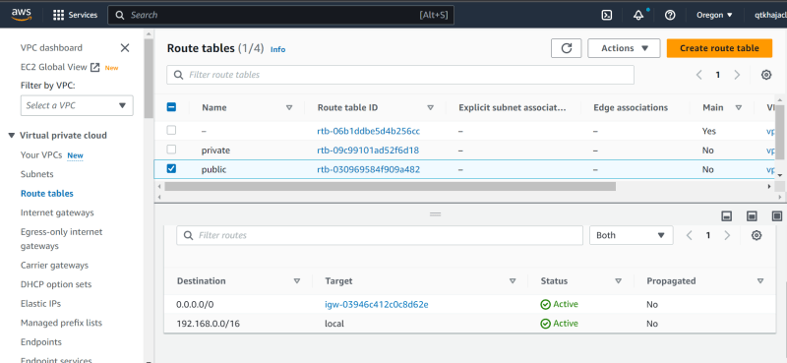
* Now we need to associate private route table with 4 subnets and public route table with 2 subnets. <https://github.com/asquarezone/TerraformZone/commit/b158695ce14d57e573a9490fedc3a6e93ff44569> for the changes done

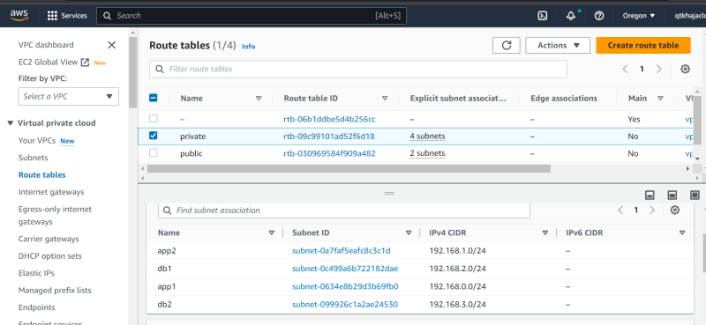

**Creating RDS DB Instance (db)**

* Manual Steps:
  + DB Subnet Group: This is more than one subnet where the databse has to be created
  + Security Group:
    - mysql: open 3306 port with in vpc
  + Database Engine: mysql
  + size: db.t2.micro
  + credentials: username and password
* Create security Group: <https://github.com/asquarezone/TerraformZone/commit/01193b090c73deb206bb5a7958cb1ece8145c90a> for changes
* Add db subnet group <https://github.com/asquarezone/TerraformZone/commit/217c295f55a88521a0d2b887065f390b6dac3f29> for changes
* Create rds instance. <https://github.com/asquarezone/TerraformZone/commit/a2d123044700aca6f3e850439236a746f2ed3287> for the changes done  
  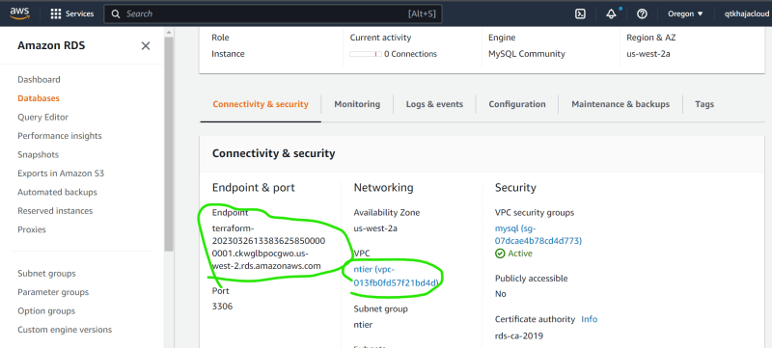
* Lets add database endpoint as output <https://github.com/asquarezone/TerraformZone/commit/a2d123044700aca6f3e850439236a746f2ed3287>   
  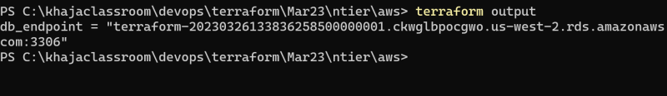

**AWS EC2 from terraform**

* Create an ec2 instance in web1 subnet
* Steps:
  + Create security group <https://github.com/asquarezone/TerraformZone/commit/89d90acbf7b1bf1edc45e428349d92129fa4190e>
* Create ec2 <https://github.com/asquarezone/TerraformZone/commit/eec5edeed863dc2667df4e9a05b4a5f8891e2d3b> for changes

